**DIT5401**

**Internet & Web Publishing**

*Trimester 2, Session 2020 / 2021*

Project Title:

**Awareness/Information Portal**

**[ PANDEMONIUM 19 ]**

BY

|  |  |  |  |  |
| --- | --- | --- | --- | --- |
| **No.** | | **Student ID** | | **Student Name** |
|  | **1191202709** | | **HO KO EE** | |
|  | **1191202279** | | **YONG JING PING** | |
|  | **1191202546** | | **CHAN LIN CHEE** | |
|  | **1191202516** | | **MATTHEW LABIAL JOHN** | |
|  | **1191202464** | | **CHEW ZHI PENG** | |

**Table of Contents**

**TABLE OF CONTENTS 1**

**TASK DISTRIBUTION FORM 2**

**PROJECT EVALUATION FORM 4**

**PART 1: INTRODUCTION 5**

**PART 2: PROBLEM STATEMENT/OBJECTIVES 8**

**PART 3: SCREENSHOTS OF THE WEBPAGE 9**

**PART 4: CONCLUSION 20**

**REFERENCES 21**

**APPENDIX (Meeting Minutes) 22**

**Task Distribution Form**

|  |  |  |  |  |
| --- | --- | --- | --- | --- |
| **No.** | **Student ID** | **Student Name** | **Tasks Completed** | **Signature** |
|  | 1191202709 | HO  KO EE | - User/Admin Log In  - User Register  - Forget Password  - User Feedback  - User Contact Us  - Admin Home  - Database  - Linking all pages |  |
|  | 1191202279 | YONG  JING PING | - Merchandise Menu  - Item Description  - My Cart  - Manage Product (View  List & Delete)  - Add New Product  - Edit Product Details  - JavaScript |  |
|  | 1191202546 | CHAN  LIN CHEE | - About Us  - View Profile  - Edit Profile  - Manage User (View  List & Delete)  - View User Details  - Edit User Details  - Database |  |
|  | 1191202516 | MATTHEW LABIAL JOHN | - Navigation Bar  (Dropdown List)  - Main Page (Home)  - Rules & SOP  - Contact Us List (View  List & Delete)  - View Contact Us Details  - Print Feedback (View  List & Delete)  - View Feedback Details  - CSS (Bootstrap) |  |
|  | 1191202464 | CHEW  ZHI PENG | - View Testimonials List  (MostView/LatestStory)  - Story Page  - Manage Testimonials  (View List)  - Edit Testimonials  - Delete Testimonials  - Add Testimonials  - JavaScript |  |

**DIT5401 Internet & Web Publishing**

**PROJECT EVALUATION FORM**

|  |  |  |  |
| --- | --- | --- | --- |
| **STUDENT ID** | **STUDENT NAME** | **Peer Evaluation Total Marks (20M)**  **(For Evaluator Use)** | **Project + Peer Evaluation**  **(For Evaluator Use)**  **(40M+20M)** |
| **1191202709** | **HO KO EE** |  |  |
| **1191202279** | **YONG JING PING** |  |  |
| **1191202546** | **CHAN LIN CHEE** |  |  |
| **1191202516** | **MATTHEW LABIAL JOHN** |  |  |
| **1191202464** | **CHEW ZHI PENG** |  |  |

|  |  |  |  |  |  |  |  |  |  |
| --- | --- | --- | --- | --- | --- | --- | --- | --- | --- |
| **1** | **Very Poor** | **2** | **Poor** | **3** | **Average** | **4** | **Good** | **5** | **Excellent** |

|  |  |  |
| --- | --- | --- |
| **Criteria** | **Marks** | **Comments/ Remarks** |
| 1. Content (User/Customer)  * Content relevance, appropriateness, organization and presentation |  |  |
| 1. Content (Administrator):  * Content relevance, appropriateness, organization and presentation |  |  |
| 1. Graphics & CSS |  |  |
| 1. Hyperlinks |  |  |
| 1. Form |  |  |
| 1. Extra features (video, javascript) |  |  |
| 1. Overall design |  |  |
| 1. Report (Hard copy & Softcopy) |  |  |
| **Total (40)** |  |  |

**PART 1: INTRODUCTION**

Our project is mainly regarding the Covid-19 situation. We decided to choose this topic which is ‘Awareness/Information Portal’ among those 5 topics because we feel that there are still lots of people who don't really know how serious the current pandemic is. Furthermore, we hope that by looking at the information on our website and story shared by users around the world with their experience, people will have a better understanding of the situation and know how to take precaution on it.

**Project Purpose**

The name of our webpage is ‘Pandemonium 19’. The purpose of our project is to design/create a website that allows users to find the information about the current pandemic easily and also to allow users to purchase some merchandise like masks and hand sanitizers. Besides that, our website allows users around the world to share their experience or story of Covid-19 or even how to prevent it. This action is good for those people who do not know how serious this pandemic is and how to prevent it efficiently. Other than that, we are to create a different interface for admin sites which allow admin users to manage the user, products data and so on. For example: when a normal user logged in to the website, it will bring the user to the user interface; In the other hand, if an admin is logged in it will bring the user to the admin page.

**Project Scope**

1. ‘Pandemonium 19’ is designed to allow users to view the cases of the pandemic around the world and also to have an extra knowledge about the movement control order / relaxed movement control order.
2. Besides that, it is also designed to allow users to purchase our merchandise.
3. For these websites, the user must have an account and are logged in before they can do anything.
4. The project will be conducted from 10 December 2020 to 02 March 2020
5. The project will be conducted online due the Covid-19 pandemic.
6. The project will allow users to share their story to others around the world.

**System Features**

* **Admin & User**
  + Log in Page: Prompt existing users to log in their account in order to access our website.
  + Register Page: Prompt new users to signup/register a new account in order to access our website.
  + Forgot Password Page: Send a reset password email to user with default password, abc123.
* **Admin**
  + Admin Home Page: (Landing page) Menu of all available pages.
  + Manage User Page: View/Edit/Delete users from the database.
  + Manage Product Page: View/Edit/Delete/Add products to the database.
  + Manage Testimonial Page: View/Edit/Delete/Add testimonials to the database.
  + Contact Us List Page: View/Delete the records on the database which users requested us to contact them.
  + Print Feedback Page: View/Delete user feedback on the database.
  + Navigation Bar: Aid admin to accessing other pages.
* **User**
  + User Home Page: (Landing page) Display the number of Covid-19 cases and related tabulated statistics. Also, display the rules & SOP in Malaysia.
  + Merchandise Menu Page: Display a menu list of our merchandise items, such as face masks and sanitizer.
  + Item Description Page: Display the details of particular item after the user clicking an item.
  + My Cart Page: Display all the records of user added items to the cart.
  + Covid-19 Testimonials List Page: Display the testimonials/stories regarding to Covid-19. Can be sorted by storyID (default) or based on the number story views.
  + About Us Page: Display the information and photos of the website's creators.
  + Contact Us Page: Allow users to leave a message to the admin and once the admin sees the message, we will reply as soon as possible.
  + Feedback Page: Allows users to rate on the website or drop down some comments regarding the websites.
  + View Profile Page: Display the important information of user.
  + Edit Profile Page: Allow users to modify their personal information details.
  + Navigation Bar (with drop down list): Aid user to accessing other pages.
  + Footer: Include the website’s logo and have a navigation to Contact Us page.

**PART 2: PROBLEM STATEMENT/OBJECTIVES**

**Problem Statement**

Ideally, users should be able to get all their needs regarding Covid-19 in one go. In reality, only some of this is true. In this specific case, multiple websites need to be viewed in order for the user to satisfy their needs regarding Covid-19, they need to interact with various sources as well, which may be inconsistent. At any moment, information that a user viewed can be debunked as fake. In consequence, a user is misinformed, and may cause mass misinformation if shared with other people. Other than that, the speed on which important information may be delayed to the user if access to this sort of information is hard, this will cause hardship between ill-informed persons. The problem may be small, but over many reiterations, it may cause a loss or big hardship in the users’ time, or convenience.

**Objective**

The main objective for this project is to prepare a platform on which users can get their needed dose of Covid-19 information securely and speedy. It would make acquiring information a better experience and more convenient for users with a good user-friendly and intuitive interface. This method of information sharing could be beneficial for our earth as well as ourselves, as it avoids paper and conveys all information digitally, no physical form of touch is needed, promoting sanitary methods of conveying information. Not only that, as this project conveys everything Covid-19, it supports the ability for commerce as well. It attempts to boost the use of e-Commerce to be commonly accepted in our society.

**PART 3: SCREENSHOTS OF WEBPAGE**

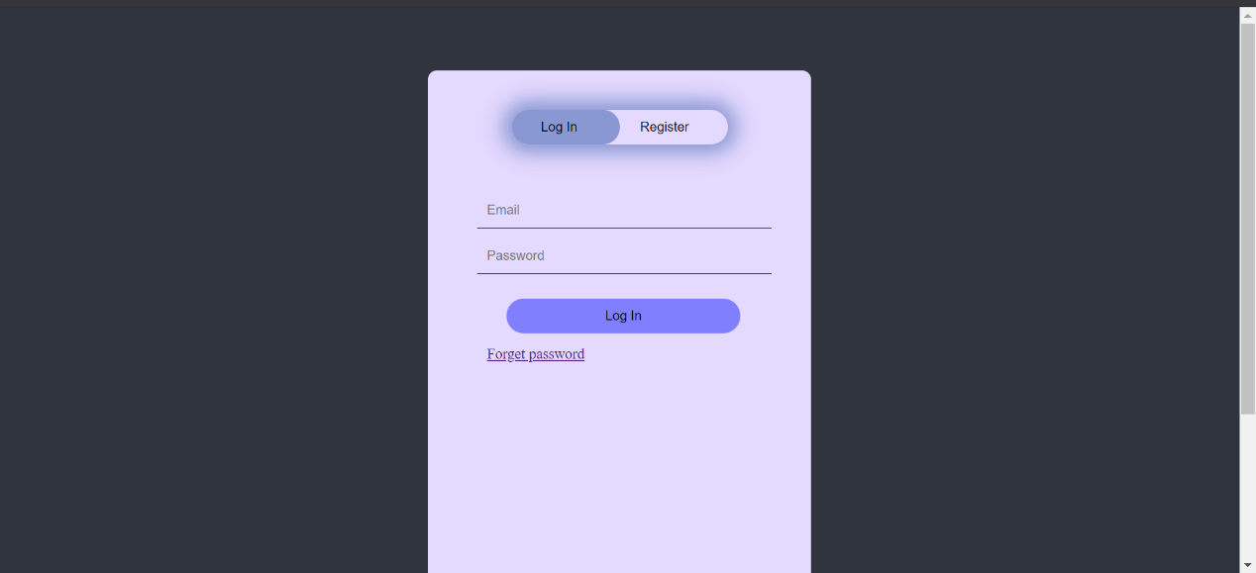

**Figure 1: Log in Page**

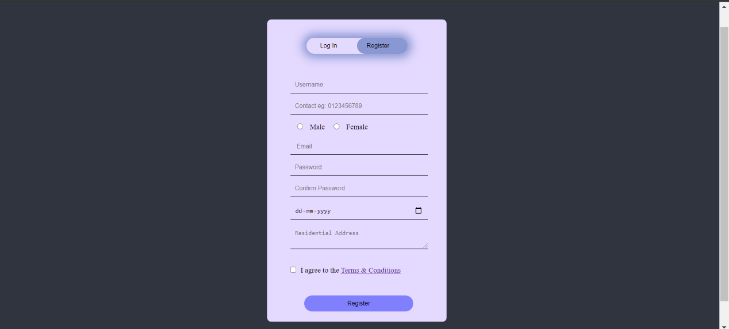

**Figure 2: Register Page**

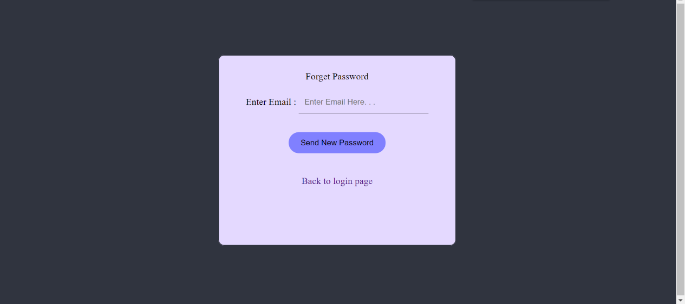

**Figure 3: Forget Password Page**

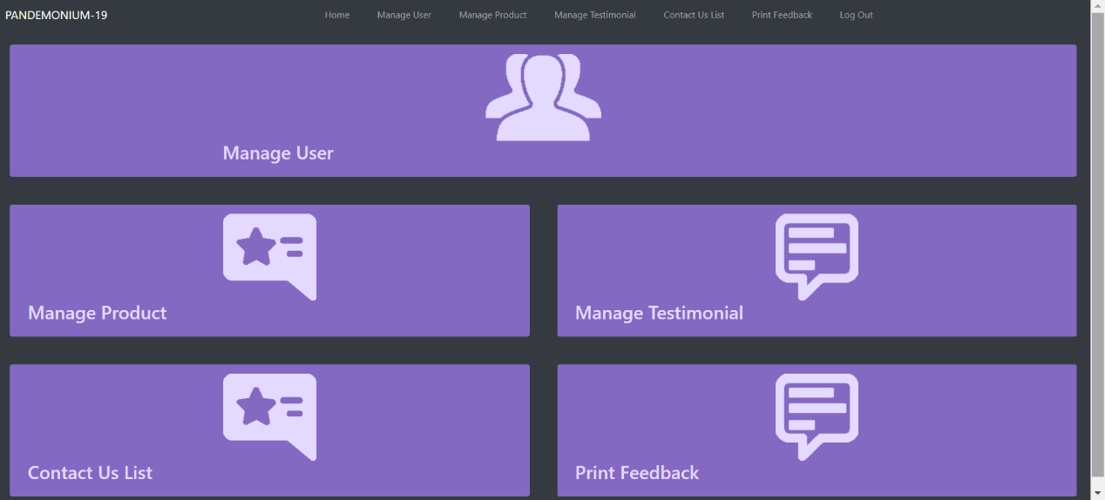

**Figure 4: Admin Home Page (Landing Page)**

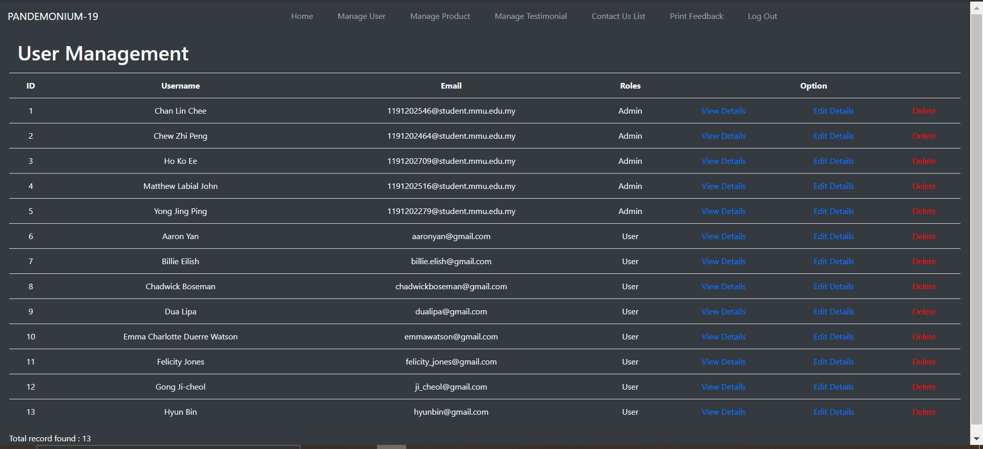

**Figure 5: User Management (View List & Delete)**

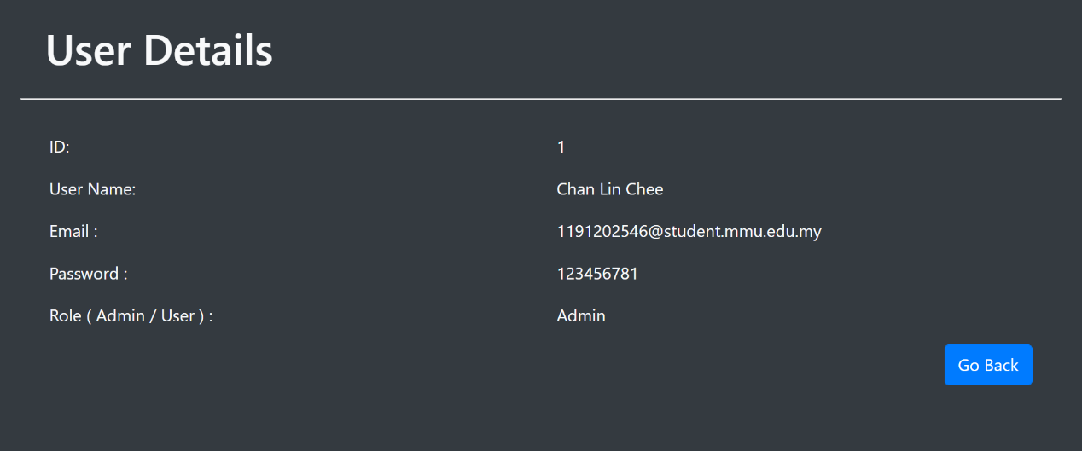

**Figure 6: View User Details**

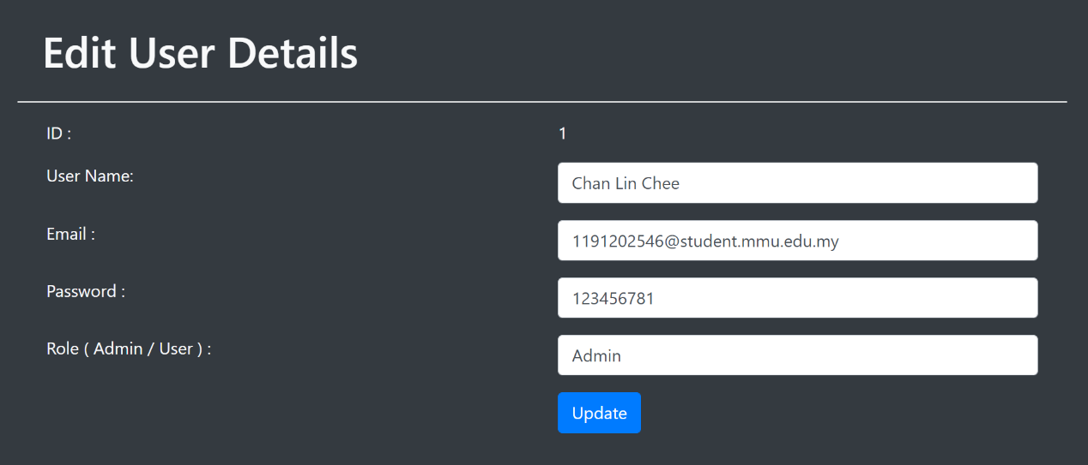

**Figure 7: Edit User Details**

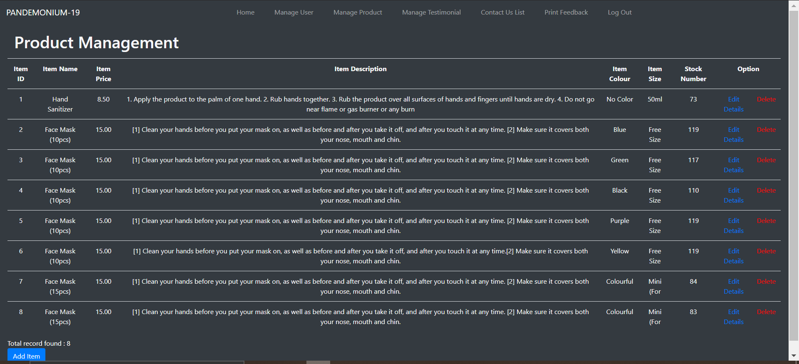

**Figure 8: Product Management (View List & Delete)**

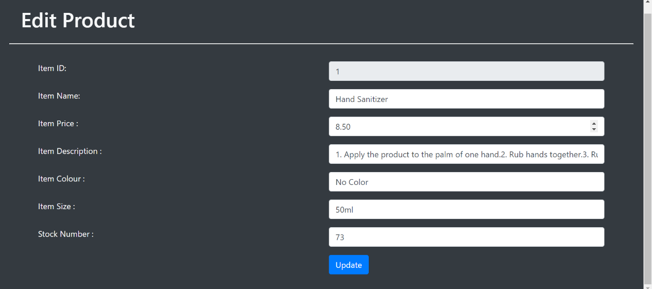

**Figure 9: Edit Product**

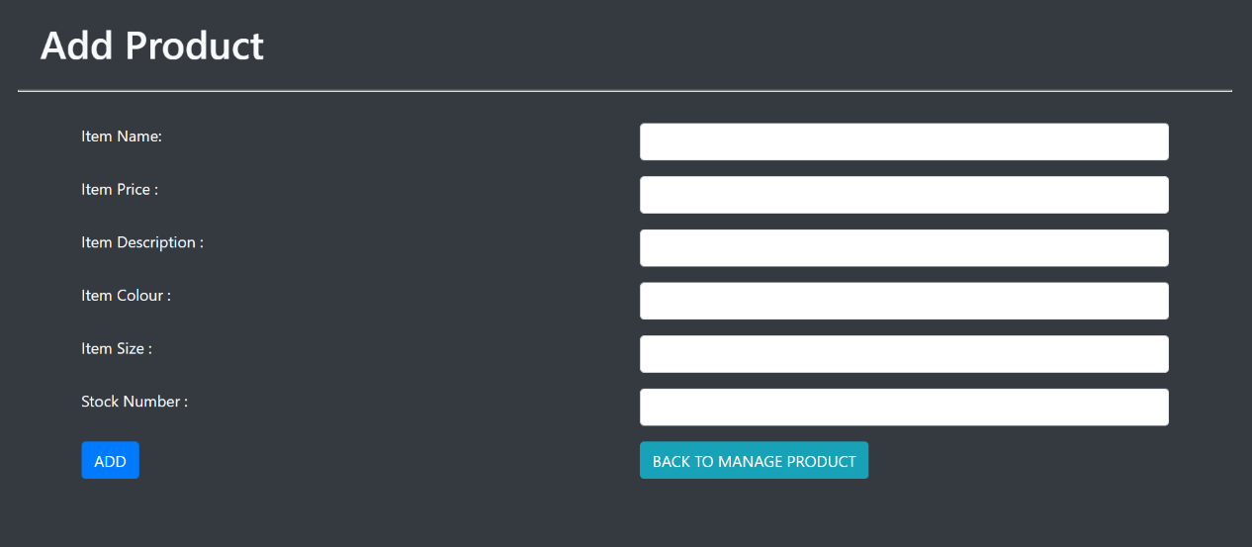

**Figure 10: Add New Product**

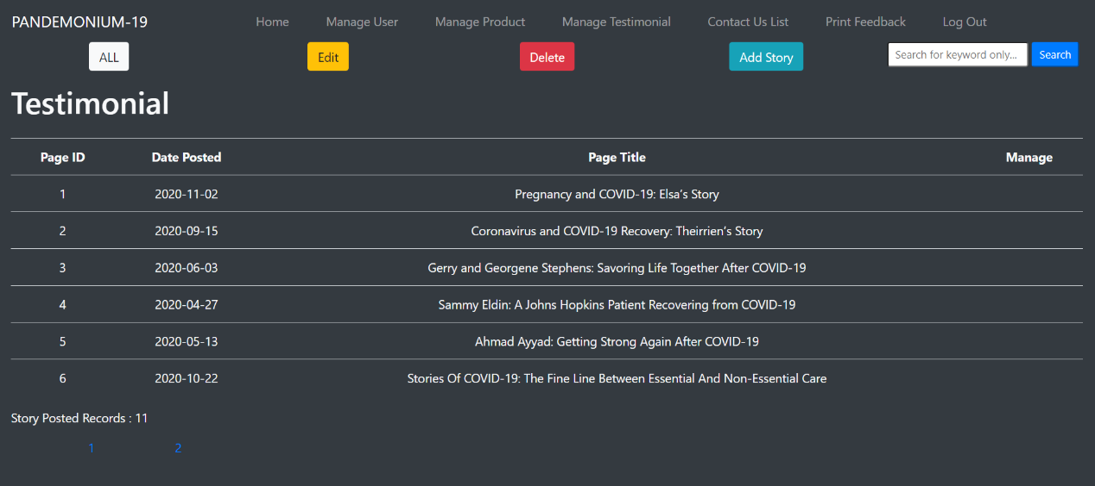

**Figure 11: View Testimonial List**

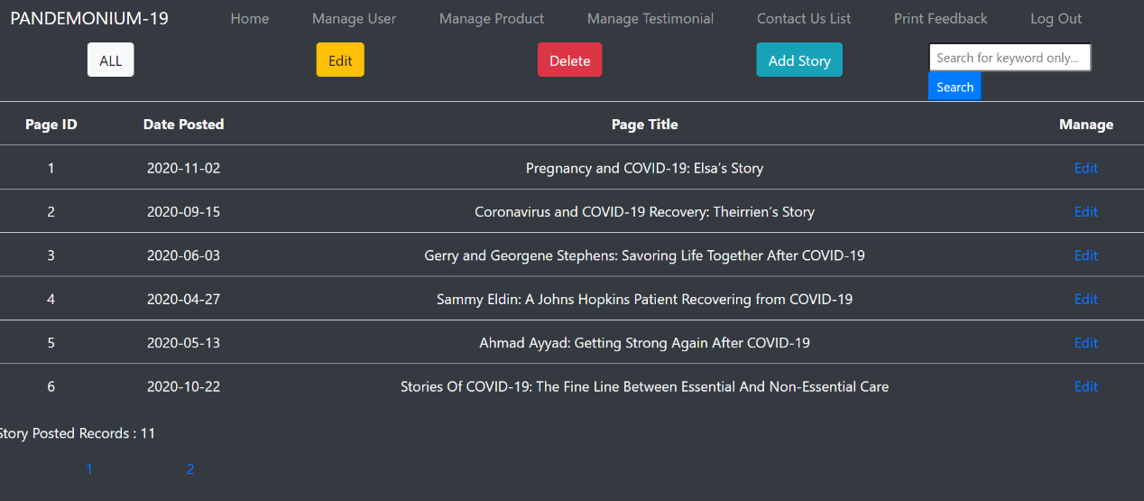

**Figure 12: Testimonial List (For Edit)**

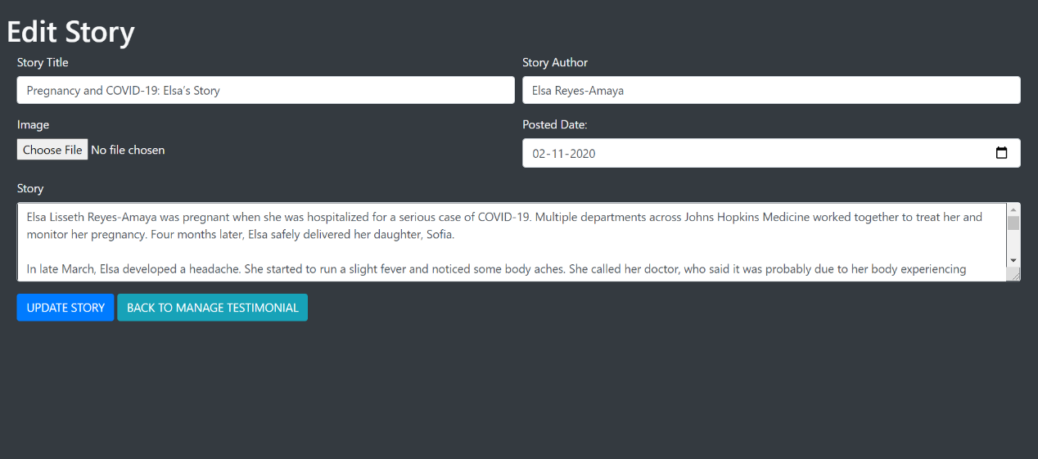

**Figure 13: Edit Story**

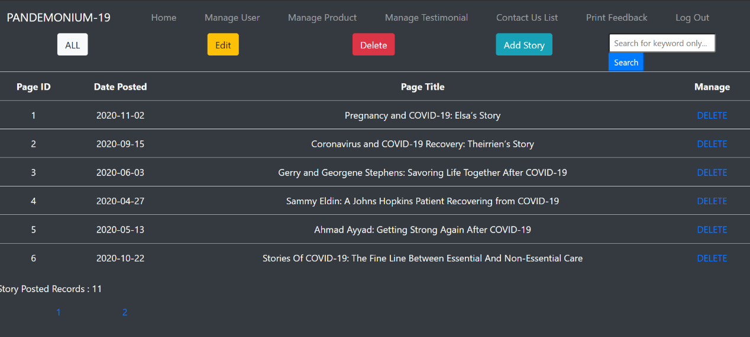

**Figure 14: Testimonial List (For Delete)**

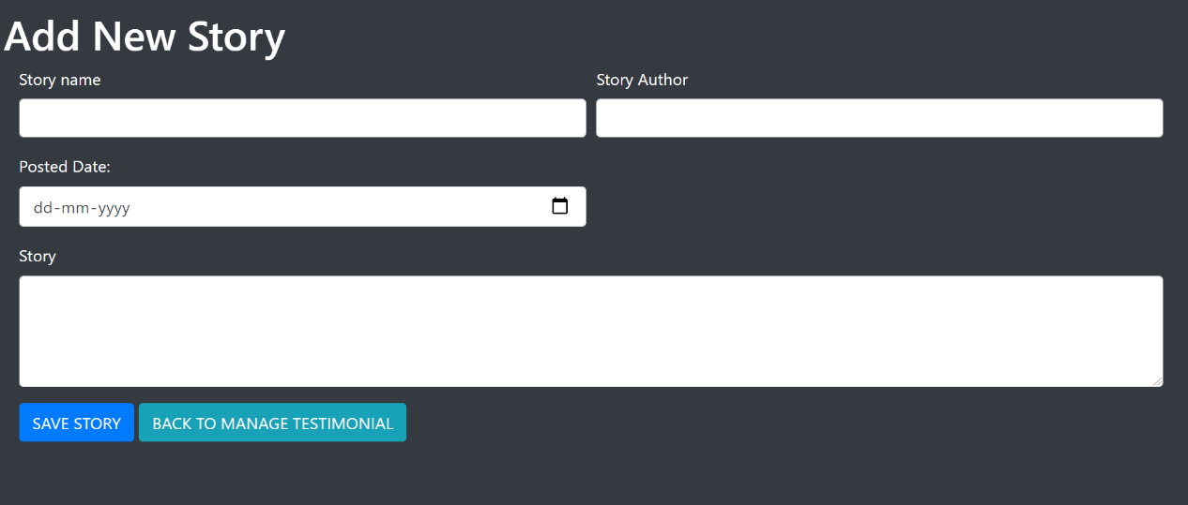

**Figure 15: Add New Testimonial**

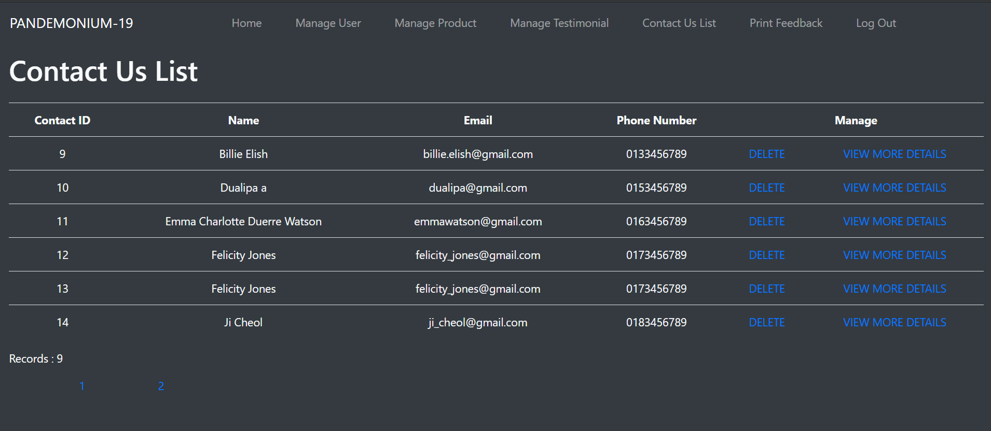

**Figure 16: View Contact Us List**

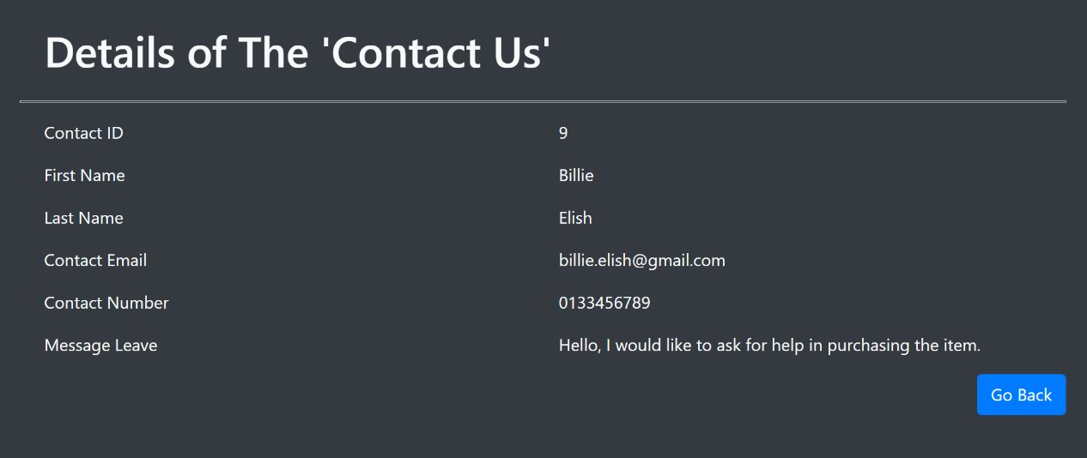

**Figure 17: View Contact Us Record Details**

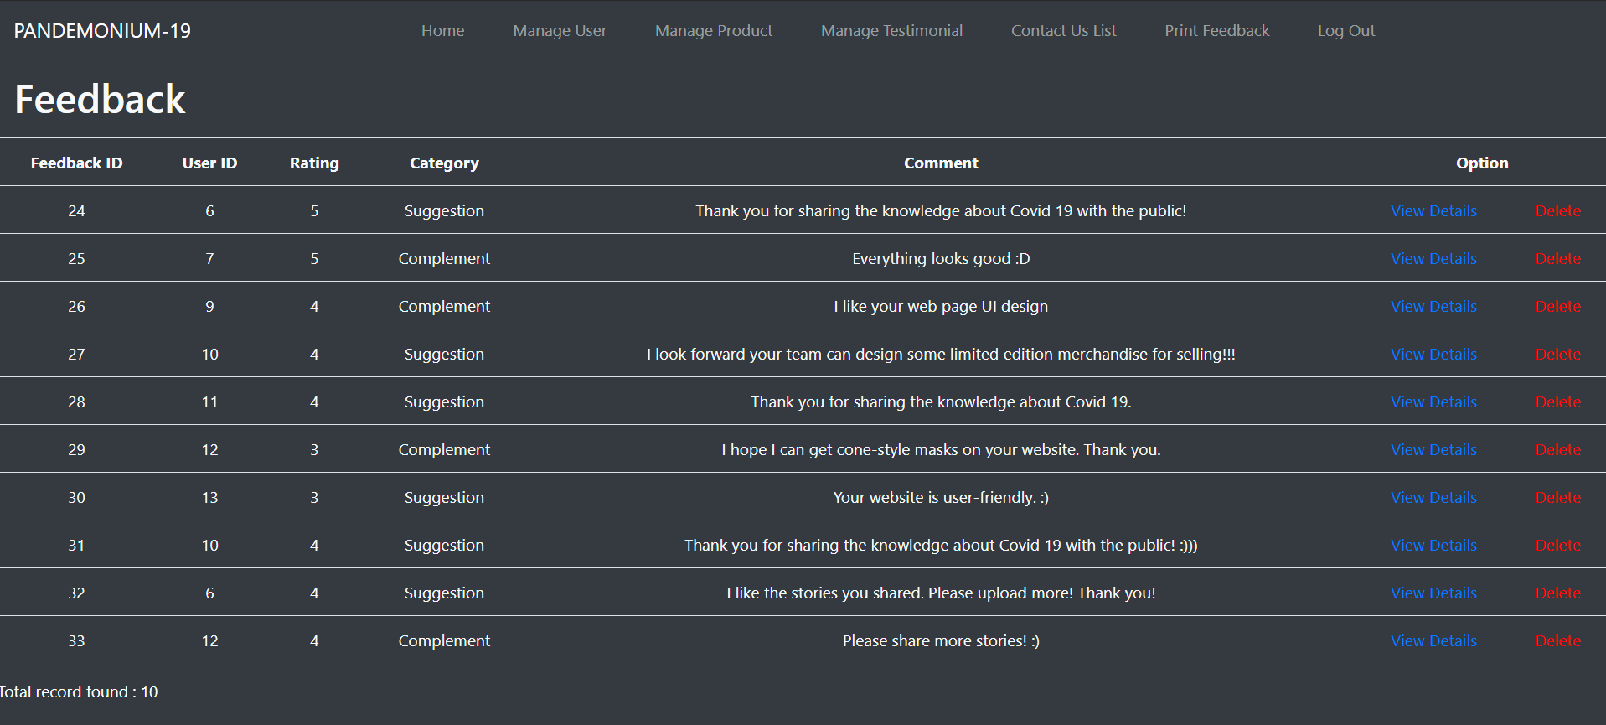

**Figure 18: View Feedback List**

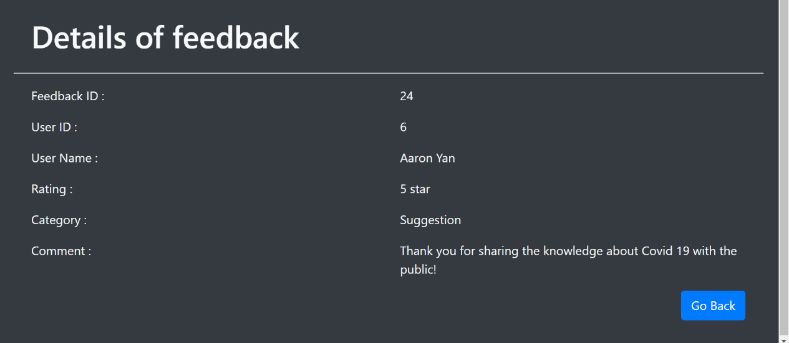

**Figure 19: View Feedback Record Details**

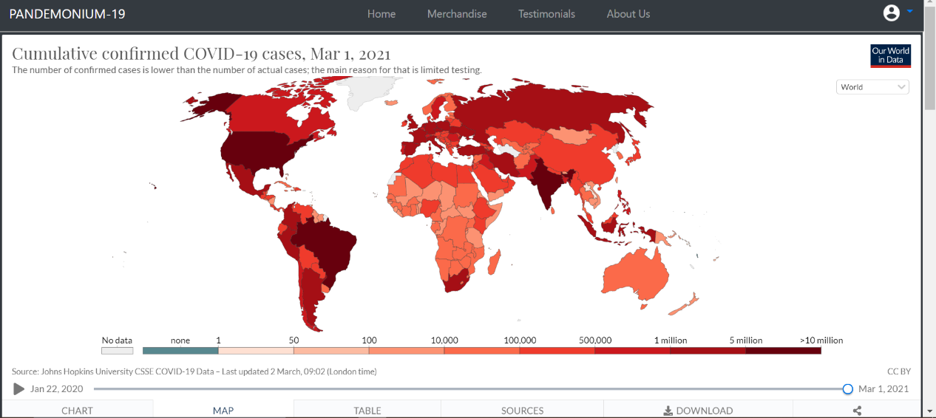 **Figure 20: User Home Page (Landing Page)**

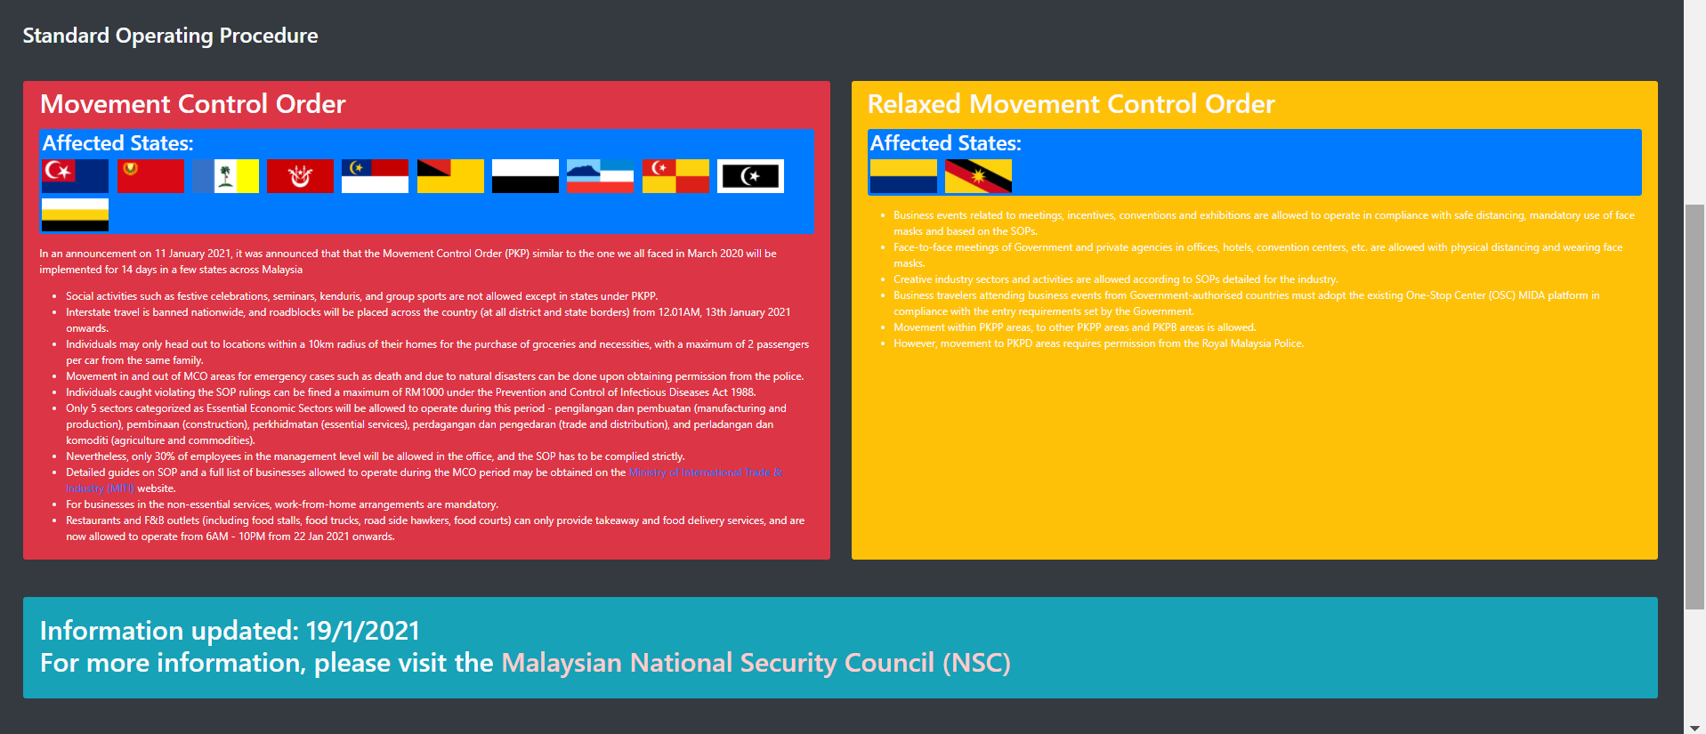

**Figure 21: SOP (under Main Page)**

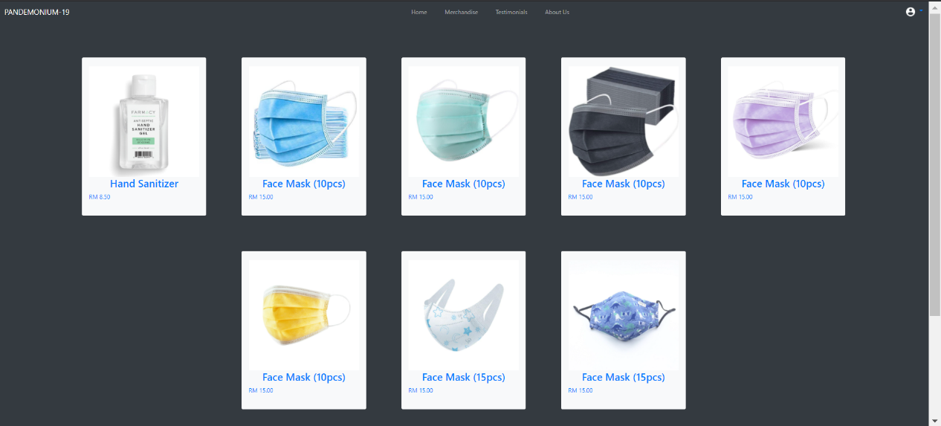

**Figure 22: Merchandise Menu Page**

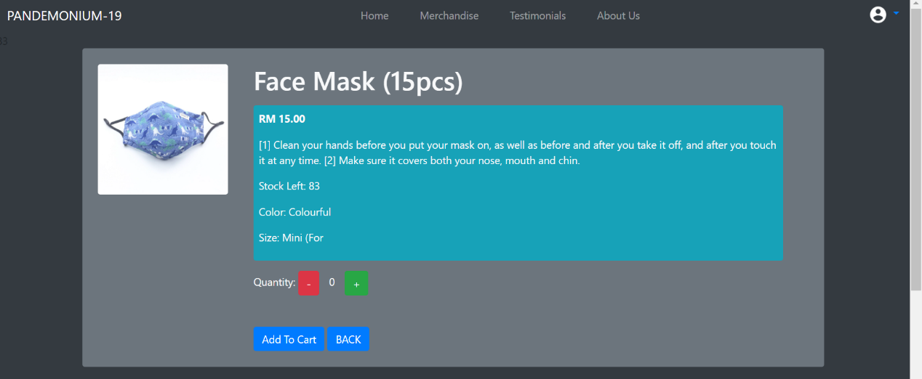

**Figure 23: Item Description Page**

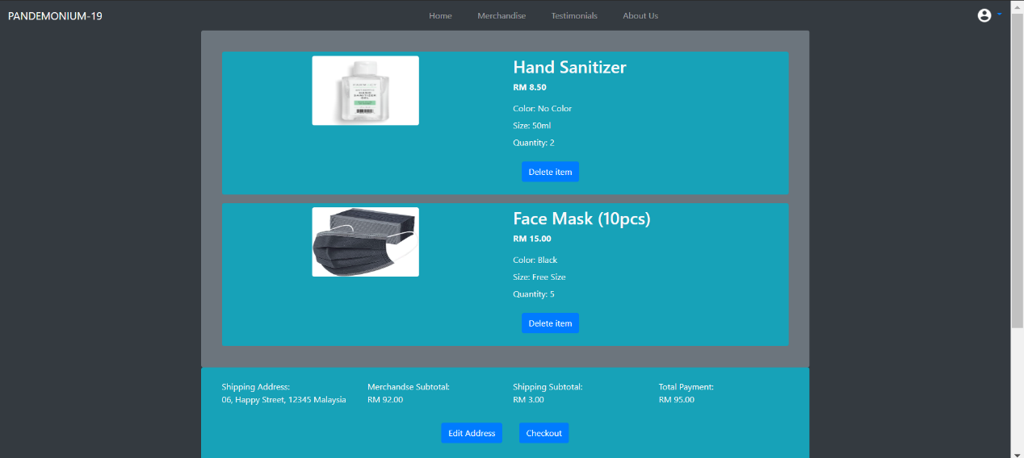

**Figure 24: My Cart (User Cart)**

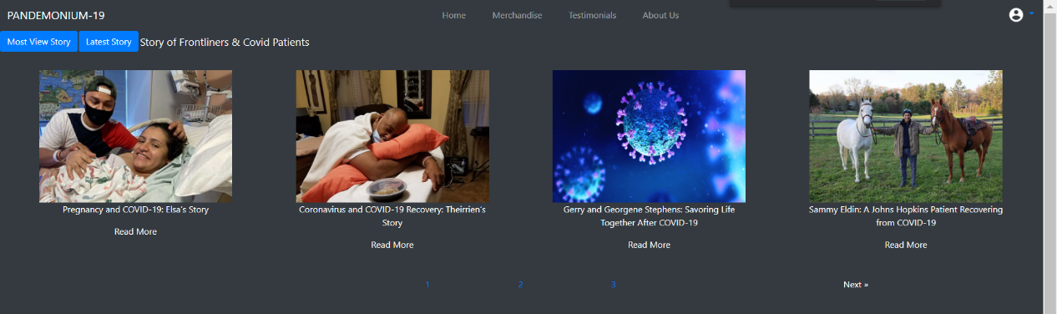

**Figure 25: Testimonials List Page**

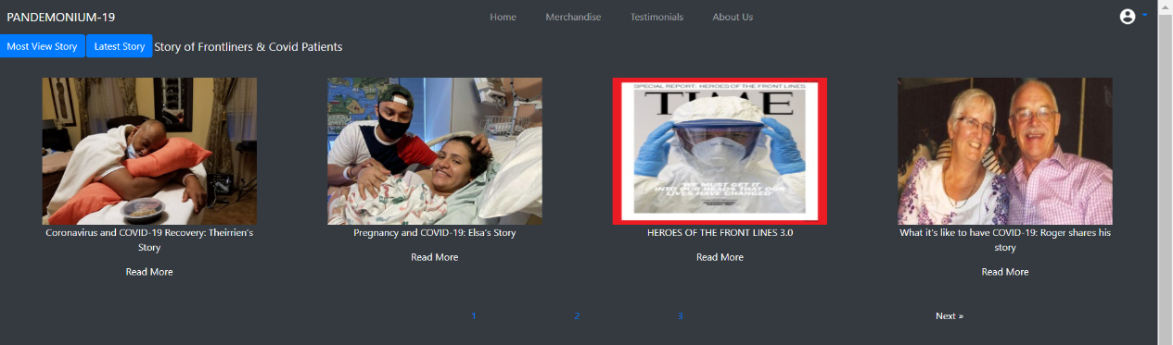

**Figure 26: Testimonials List Page (Most View)**

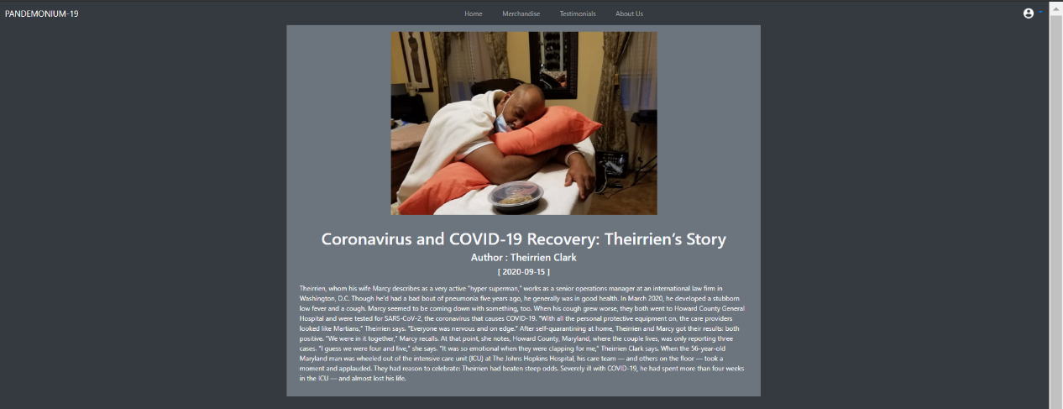

**Figure 27: Story Page**

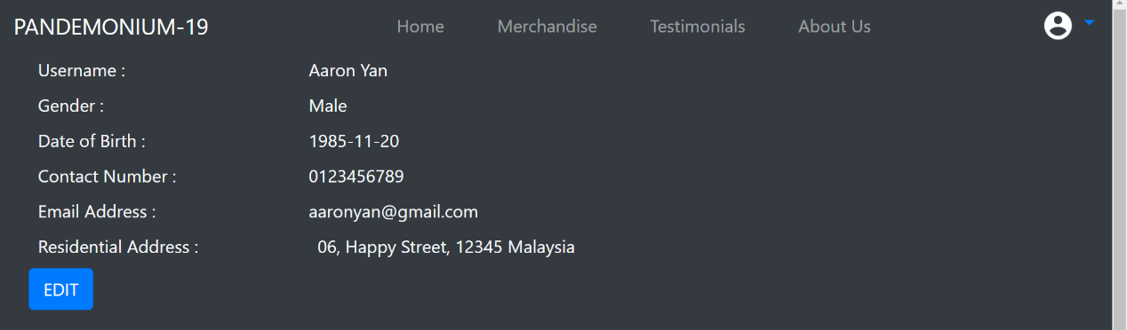

**Figure 28: View Profile Details**

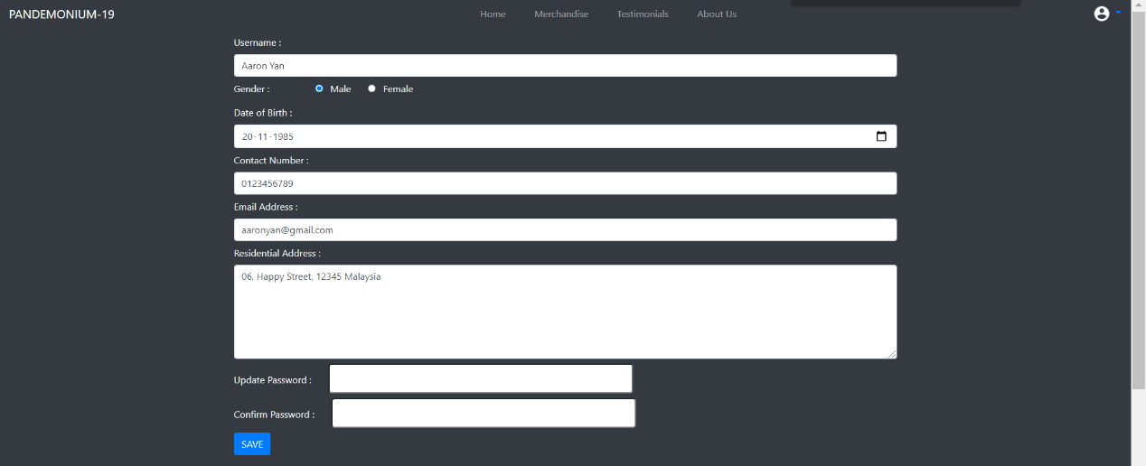 **Figure 29: Edit User Profile**

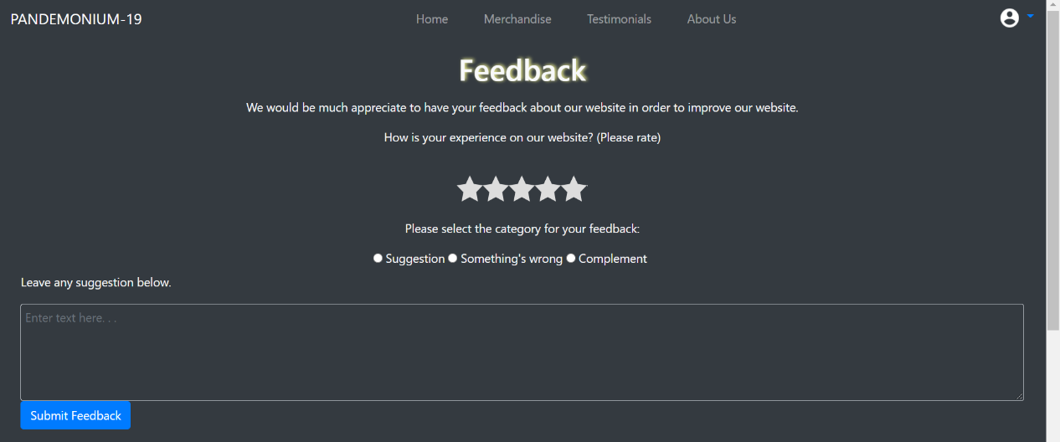

**Figure 30: Feedback**

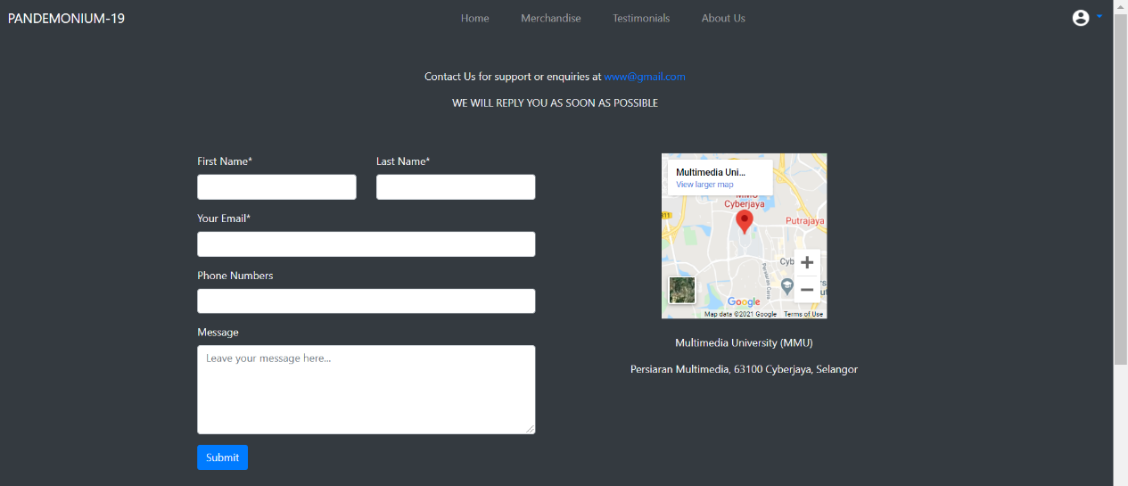

**Figure 31: Contact Us**

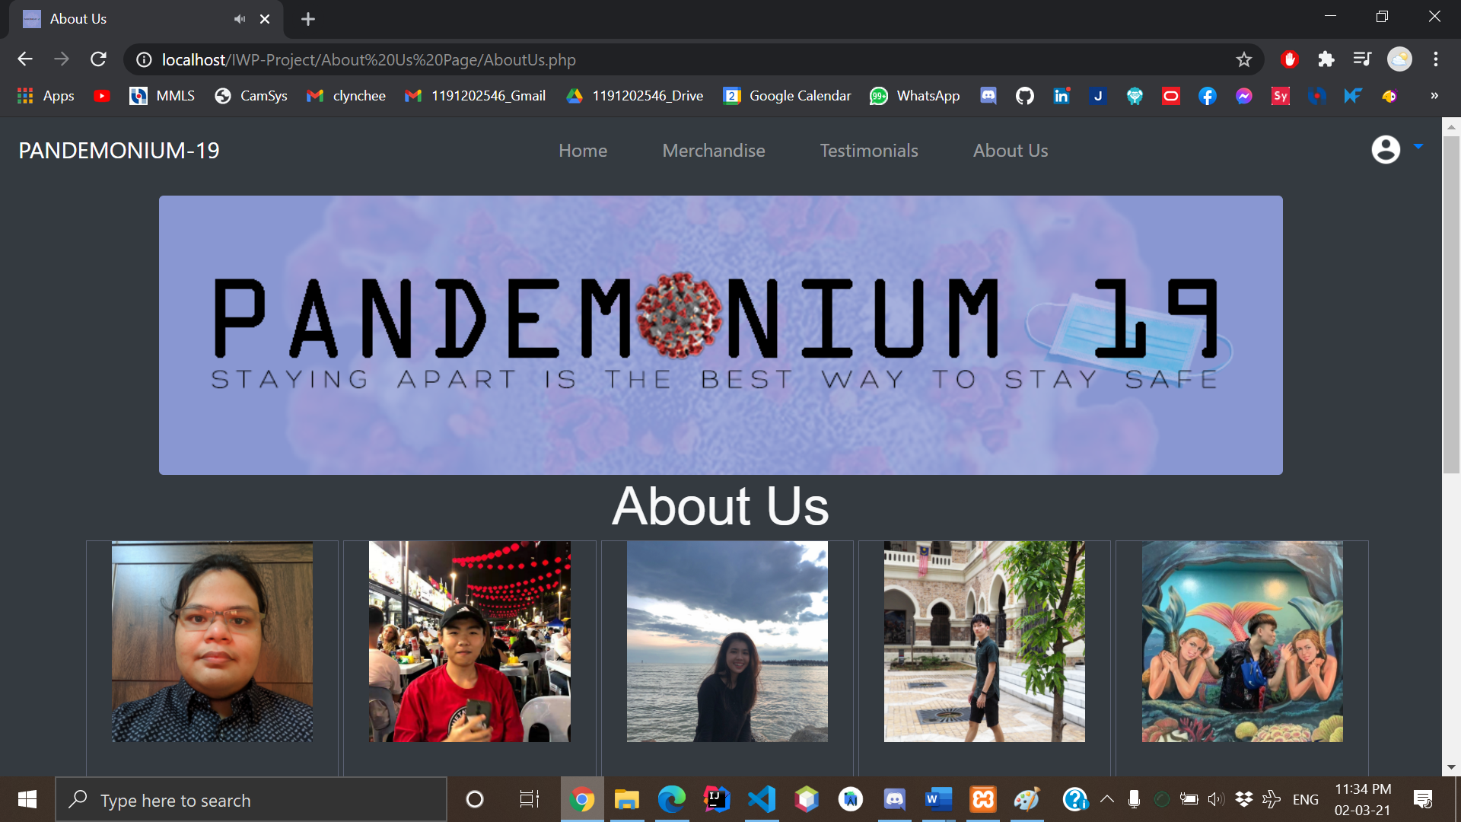

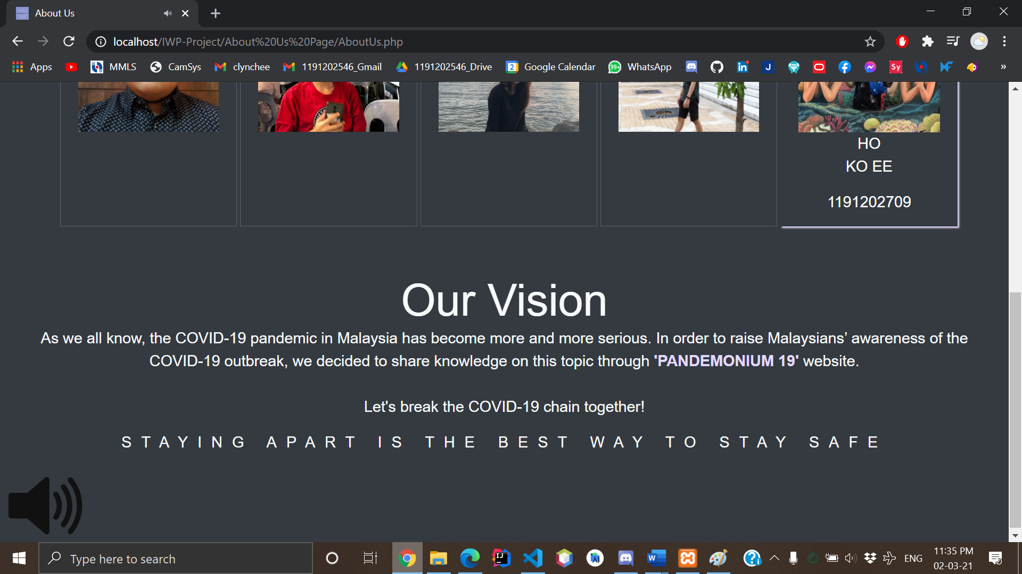

**Figure 32: About Us Page**

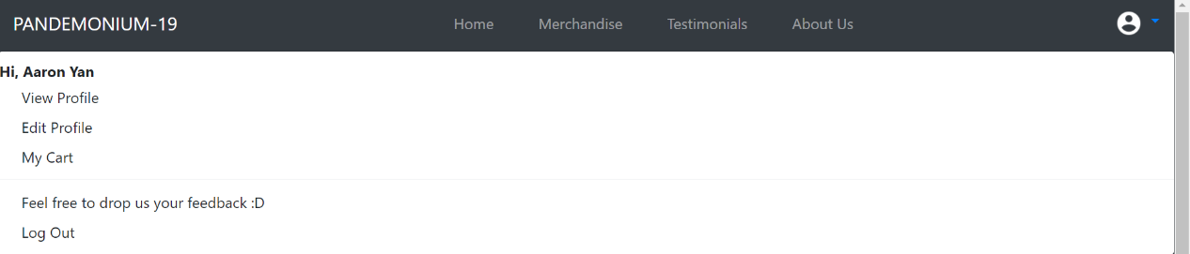

**Figure 33: Navigation Bar (with Dropdown List)**

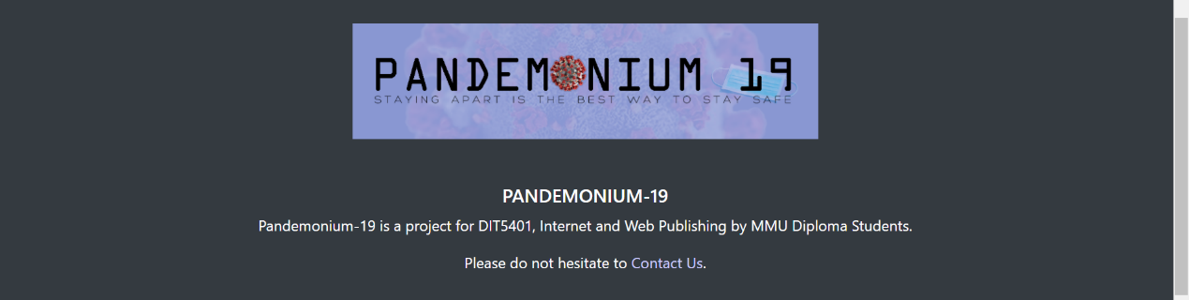

**Figure 34: Footer**

**PART 4: CONCLUSION**

With the good communication and helping between each other of the members of the project which are Chan Lin Chee, Matthew Labial John, Yong Jing Ping, Ho Ko Ee, and Chew Zhi Peng, the completion of this project could not be completed without the participation of them. Their amazing contributions are deeply appreciated and helpful which is encouragable between each other. The process of the project is tough, especially in this project we face a lot of challenges like deciding the title of our project, we used voting in order to make a final decision to decide which type of project is the most suitable to develop, at the end we choose to develop a Covid-19 Awareness Website which the title is “Pandemonium 19”. The reason why we are choosing the title is because we want people to have awareness, to adopt the new normal, daily Covid-19 doses, and be concerned about the world's current situation and appeal to them to buy the pandemic prevention items, so our group decided to choose this title as our project since a lot of people are still not cautious about the pandemic. The second problem we encountered is when we need to decide the database of the phpMyAdmin, it takes us one week to complete the complete database of the project title. As a member of Group 8, I, Chew Zhi Peng, want to thank all the hard work and the help of our Group 8 fellas. Moreover, we respect and thank Madam Aziah Binti Ali for giving us a chance to do this project work and giving us all the support and guidance, which make our project accurate and successful.

We are really grateful because we managed to finish our project in the adequate time given by Madam Aziah. Last but not least, we would like to express our gratitude to our friends and anyone who participated in this project for support and encouragement to spend some time with us.

**REFERENCES/BIBLIOGRAPHY**

1. Behr, Z. (2020, November 23). *Pregnancy and COVID-19: Elsa’s Story*. Johns Hopkins Medicine. <https://www.hopkinsmedicine.org/coronavirus/patient-stories/elsa-reyes-amaya.html>
2. Whiteman, T. (2020, September 18). *Coronavirus and COVID-19 Recovery: Therrien's Story*. Johns Hopkins Medicine. <https://www.hopkinsmedicine.org/coronavirus/patient-stories/theirrien-clark.html>
3. Matsos, S. (2020, June 4). *Gerry and Georgene Stephens: Savoring Life Together After COVID-19*. Johns Hopkins Medicine.

<https://www.hopkinsmedicine.org/coronavirus/patient-stories/gerry-georgene-stephens.html>

1. Matsos, S. (2020a, May 18). *Ahmad Ayyad. Johns Hopkins Medicine*.

<https://www.hopkinsmedicine.org/coronavirus/patient-stories/ahmad-ayyad.html>

1. Behr, Z. (2020a, April 27). *Sammy Eldin’s Story*. Johns Hopkins Medicine.

<https://www.hopkinsmedicine.org/coronavirus/patient-stories/sammy-eldin.html>

1. *The Country Won’t Work Without Them. 12 Stories of People Putting Their Lives on the Line to Help Others During Coronavirus.* (2020, April 9). Johns Hopkins Medicine.

<https://time.com/collection/coronavirus-heroes/5816885/frontline-workers-coronavirus/>

1. N.A.(N.D).*PHP Sessions*.W3schools

<https://www.w3schools.com/php/php_sessions.asp>

**APPENDIX**

|  |  |
| --- | --- |
| **Meeting No.** | 1 |
| **Project Title** | Awareness / Information Portal [ PANDEMONIUM 19 ] |
| **Date** | 12 December 2020 |
| **Time** | 2.00 p.m. - 3.30 p.m. |
| **Venue** | Google Meet |

**ATTENDANCE**

|  |  |
| --- | --- |
| **Present** | **Absent** |
| 1. Chan Lin Chee 2. Chew Zhi Peng 3. Ho Ko Ee 4. Matthew Labial John 5. Yong Jing Ping | *none* |

|  |  |  |
| --- | --- | --- |
| **NO** | **ITEM** | **INFO/ACTION** |
| 1  1.1 | **Title Decision**  Awareness / Information Portal (Covid-19) | All |
| 2  2.1  2.2  2.3  2.4 | **Task Distribution**  Interface Design: Matthew Labial John  Database: Yong Jing Ping & Ho Ko Ee  Content Design: Chan Lin Chee  Products/Services: Chew Zhi Peng | All |
| 3  3.1  3.2  3.3  3.4 | **Concept of the website**  Daily number of cases of Covid-19 (Global & Malaysia)  Selling Merchandise  Bulletin Board / Newsletter  Quiz | All |
| 4  4.1 | **Next Meeting**  18 December 2021 | All |

The meeting adjourned at 3:30 p.m.

Prepared by: Chan Lin Chee

**APPENDIX**

|  |  |
| --- | --- |
| **Meeting No.** | 2 |
| **Project Title** | Awareness / Information Portal [ PANDEMONIUM 19 ] |
| **Date** | 18 December 2020 |
| **Time** | 1.00 p.m. - 4.30 p.m. |
| **Venue** | Google Meet |

**ATTENDANCE**

|  |  |
| --- | --- |
| **Present** | **Absent** |
| 1. Chan Lin Chee 2. Chew Zhi Peng 3. Ho Ko Ee 4. Matthew Labial John 5. Yong Jing Ping | *none* |

|  |  |  |
| --- | --- | --- |
| **NO** | **ITEM** | **INFO/ACTION** |
| 1  1.1 | **Presenting Idea**  Awareness / Information Portal (Covid-19) | All |
| 2  2.1  2.2  2.3  2.4  2.4.1  2.4.2  2.4.3  2.4.3.1  2.4.3.2  2.4.3.3  2.5  2.5.1 | **Idea Confirmation**  Initial Design:    Theme Color:    Map interface in main page with Covid Cases:  (With some pin on it to let user click it and check the cases on that particular location)    Database:  Will store data for user, merchandise, contact form, comment and rating form, survey.  Using MySQL, PHP to perform all the database tasks.  Tables include:  - User  - Merchandise Item  - Cart Item  Services  - Covid-19 Story | All |
| 3  3.1  3.1.1  3.1.2  3.1.3  3.1.4  3.1.5  3.1.6  3.1.7  3.1.8  3.1.9  3.1.10  3.2  3.2.1  3.2.2  3.2.3  3.2.4  3.2.5  3.2.6 | **Interface Pages**  User:  - Header  - Main Page  - Merchandise Page  - Covid-19 Testimonials  - About Us  - Contact Us  - Feedback  - Log In  - Log Out  - Footer  Admin:  - Admin Home Page  - Manage Product  - Manage Testimonials  - Print User Feedback  - User Management  - Admin Log in / Logout | All |
| 4  4.1  4.2 | **Website Name & Slogan**  Website Title:  Pandemonium 19  Website Slogan:  S T A Y   A P A R T   I S   T H E   B E S T   W A Y   T O   S T A Y   S A F E | All |
| 5  5.1 | **Next Meeting**  1 February 2021 | All |

The meeting adjourned at 4:30 p.m.

Prepared by: Chan Lin Chee

**APPENDIX**

|  |  |
| --- | --- |
| **Meeting No.** | 3 |
| **Project Title** | Awareness / Information Portal [ PANDEMONIUM 19 ] |
| **Date** | 1 February 2020 |
| **Time** | 2.00 p.m. – 4.00 p.m. |
| **Venue** | Google Meet |

**ATTENDANCE**

|  |  |
| --- | --- |
| **Present** | **Absent** |
| 1. Chan Lin Chee 2. Chew Zhi Peng 3. Ho Ko Ee 4. Matthew Labial John 5. Yong Jing Ping | *none* |

|  |  |  |
| --- | --- | --- |
| **NO** | **ITEM** | **INFO/ACTION** |
| 1  1.1  1.2  1.3  1.4  1.5  1.6 | **Progress Presentation**  At most of the page, we plan to make header and footer on it. This was the first design of our header and footer.    After a few logo selections, we decided to use this logo as our entire page logo.    This was the first design of our main page. We plan to make some dots on the map as image shown which clickable and show the statistic of the dot area.    Here are some pages design for merchandise items.  There are Merchandise Menu, Item Description and Cart page respectively.        Below are some of the testimonial page’s design.  Users are able to view the story related to Covid-19 and make some comments on it.        Some others design of the pages were shown below.  There are Contact us, Feedback, User profile page, Sign in and up. | All |
| 2  2.1  2.2  2.3 | **Solution and Next Target**  We are targeting finish 70% work include pages, logics and databases before 10 February 2021.  After the design, each one us need to implement the pages for their HTML and JavaScript. At the same time, the database can be created by using phpMyAdmin too.  Please push up the product that you’ve done for the page into GitHub. It will be easier because we can access the files and help to correct each other’s. | All |
| 3  3.1 | **Next Meeting**  14 February 2021 | All |

The meeting adjourned at 4:00 p.m.

Prepared by: Yong Jing Ping

**APPENDIX**

|  |  |
| --- | --- |
| **Meeting No.** | 4 |
| **Project Title** | Awareness / Information Portal [ PANDEMONIUM 19 ] |
| **Date** | 14 February 2020 |
| **Time** | 10.00 a.m. - 12.00 p.m. |
| **Venue** | Google Meet |

**ATTENDANCE**

|  |  |
| --- | --- |
| **Present** | **Absent** |
| 1. Chan Lin Chee 2. Chew Zhi Peng 3. Ho Ko Ee 4. Matthew Labial John 5. Yong Jing Ping | *none* |

|  |  |  |
| --- | --- | --- |
| **NO** | **ITEM** | **INFO/ACTION** |
| 1  1.1  1.2  1.3  1.4  1.5  1.6  1.7  1.8  1.9  1.10 | **Finalized User Pages Content**  Home  (With iframe include for Covid-19 data, SOP Rules)  Merchandise  (Merchandise Menu, Description and Cart page)  Testimonials  (Testimonials Menu with Most View and Latest Story sort and Story page)  About Us  (Our pictures, name, student ID, vision and slogan)  Sign in, register and forget password.  Header and footer.  View Profile  (Showing the user data)  Edit Profile  (Allow user to edit their data.)  Feedback  (Allow user to send feedback)  Contact Us  (Allow user to send some message to us where this page included map iframe.) | All |
| 2  2.1  2.2  2.3  2.4  2.5  2.6  2.7 | **Finalized Admin Pages Content**  Home  (Include all the pages in admin)  Manage User  (Show up all the registered user which include admin user too)  Manage Product  (Show up all the merchandise items in the database)  Manage Testimonials  (A list for all the stories)  Contact Us List  (A user list who wish to contact us)  Print Feedback  (A feedback form from users)  Header  (Include all the pages and a log out button) | All |

The meeting adjourned at 12:00 p.m.

Prepared by: Yong Jing Ping